**Comparative Analysis of Heights in Volleyball and Swimming Teams**

Date: August 13, 2025

Group 4: Linda Li, Jessica Yo, Octave

**Introduction**

This report presents a comparative analysis of the average heights of athletes in the men’s and women’s volleyball and swimming teams across multiple colleges. The data was collected from the official athletic websites of each of the respective colleges. The objective is to determine whether there is a difference in height between volleyball players and swimmers.

**Techniques Used**

* Data collection from official college’s athletic rosters
* Calculation of average heights for each team
* Comparative statistical analysis between height in sports and genders

**Methodology**

Data was scraped from official teams and transformed to dataframes with “Name” and “Height” as attributes. Separate dataframes were created for each sport and gender. Using the .mean() function, the average height of each dataframe was calculated. These averages were then compared between volleyball and swimming teams, grouped by gender.

**Findings:**

**Men’s Volleyball vs Men’s Swimming Teams**

* Men’s swimming - average height: 71.12 inches
* Men’s volleyball - average height: 71.45 inches
* On average, men’s volleyball players are slightly taller than men’s swimmers. The difference may be due to the sport’s physical demand where volleyball often requires players to reach high above the net, flavoring taller individuals.

**Women’s Volleyball vs Women’s Swimming Teams**

* Women’s swimming - average height: 65.80 inches
* Women’s volleyball - average height: 67.63 inches
* Similarly, to the men’s team, the volleyball players are, on average, taller than the swimmers.

**Conclusion**

Based on the data from multiple college teams, volleyball players are, on average, taller than swimmers in both men’s and women’s teams. While the differences are relatively small, the physical demands of volleyball may influence athlete selection in the volleyball teams.

**Appendix A: Average Heights Among Men’s Athletes**

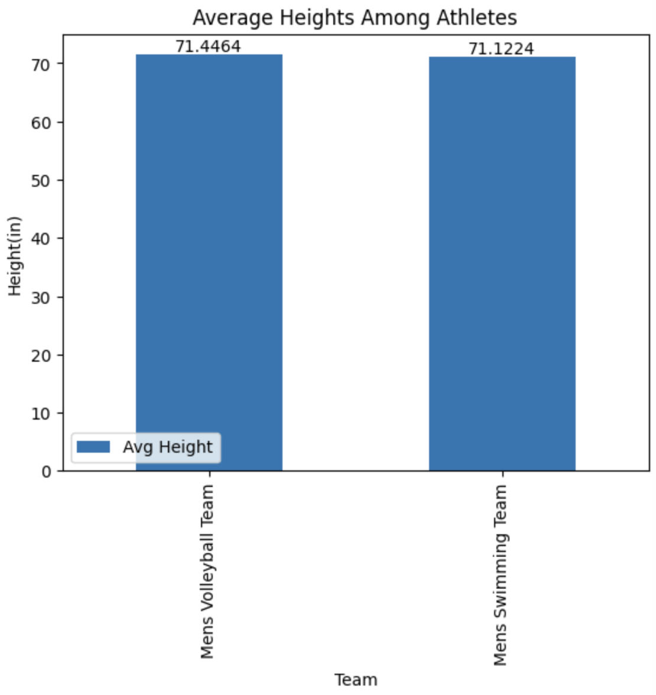

**Appendix B: Average Heights Among Women’s Athletes**

